**Registration for TAPD Summer Recreation Baseball and Softball leagues** 





**Tremont Parks & Recreation Center – 2025 Registration Form**

Parent Name ______________________ Email ______________________________

Address ___________________________ City ________________ Zip ___________

Home # _____________________ Cell # ________________ Work #_____________

**Emergency Contact: __________________ Phone # _________ Relationship ________**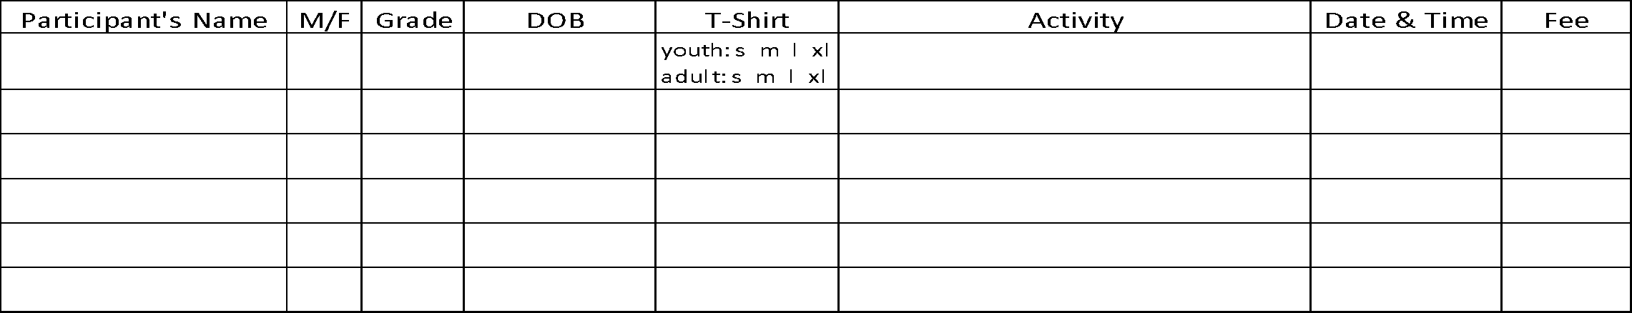

Are you interested in coaching Y__N_ Coach Shirt Size____****Fan shirt orders–pre-order $15.00****

Option A: White Option B :White Option A: Maroon Option B:Maroon

Fan Shirts Circle/Quantity shirt size: Adult S M L XL XXL Youth S M L XL

Circle: Baseball or Softball : Shirt Design 



*Once registration is completed, we will establish an evaluation date for those leagues with multiple teams (with the exception of Little Turks T-Ball and 6u Modified Coach Pitch). We ask that registration forms be turned in **as soon as possible** . If you are interested in coaching one of the recreation teams, please indicate that on your registration form. Tremont Area Park District intends to allow **all** children the opportunity to participate. If fees are a concern, please let us know and confidential arrangements will be made.

**NEW: Girls 8u and up will be required to have an infield face mask before first practice.**

